Development Documentation

General Layout & Colour Scheme
Homepage code
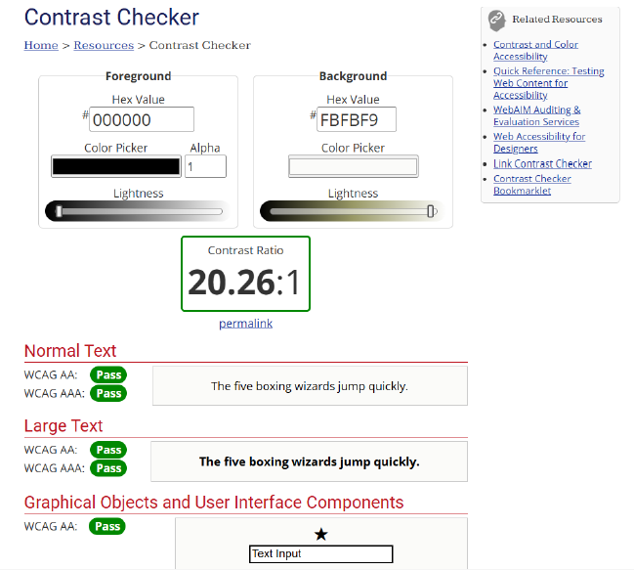
Homepage
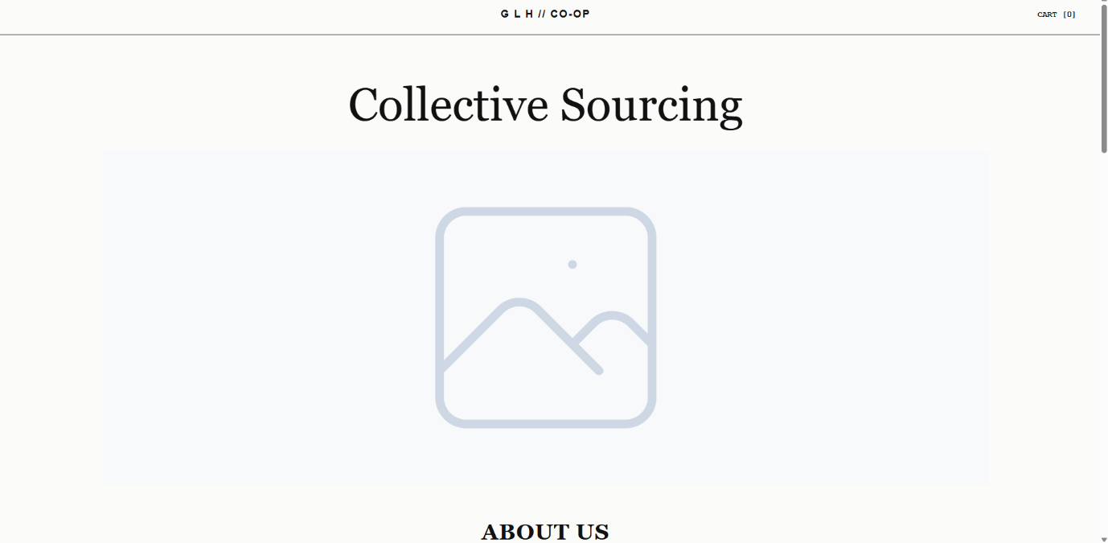
GENERAL THEME CODE
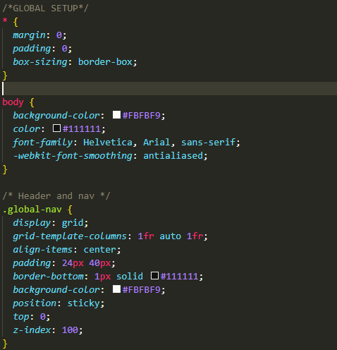
During the development of the global layout, I ensured the background colour was set to #FBFBF9 (Porcelain), which perfectly matches the colour scheme established in my original design documents I originally chose this specific off-white colour because a softened background significantly reduces screen glare and helps prevent user eye strain during prolonged browsing, which greatly improves overall usability.
Furthermore, when paired with pure black text (#000000), this background creates a highly compliant contrast ratio of 20.26:1. This was a design decision to ensure strict WCAG accessibility compliance. It guarantees the website remains highly readable for visually impaired users, partially sighted users, and those with colour blindness, while also fulfilling my non-functional requirements.
To further enhance site usability, I wrapped the main 'G L H // CO-OP' logo in an anchor tag linked to the homepage. Making the top-centre logo a clickable 'Home' button is a universally recognised web design standard. Black Box functional testing confirmed this behaves as expected, ensuring the layout remains highly intuitive for users, allowing them to easily re-establish their position on the site if they get lost.

Content Population & UI Typography Testing
During the development of the Information Hub, I needed to accurately simulate the final visual layout to test the dynamic scaling of my CSS. Rather than repeating standard 'Lorem ipsum', I utilised AI generated text to populate the UI. This provided a realistic volume of varied content, allowing for more robust Black Box UI testing of text wrapping, line heights, and container overflow limits.
To ensure I strictly met the ethical and legal guidelines regarding data validity, this AI generated text has been formally declared and cited within my Assets Log. I am fully aware that for a live production environment, these placeholders must be completely removed and replaced with verified, legally approved copy provided directly by the client. This proactive approach allows me to thoroughly test the front end architecture while eliminating the risk of displaying erroneous or unverified information to the end consumer.

Homepage Nav Bar
Homepage code
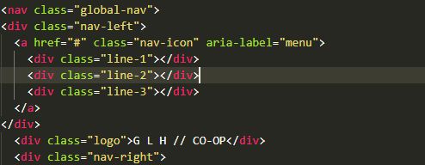
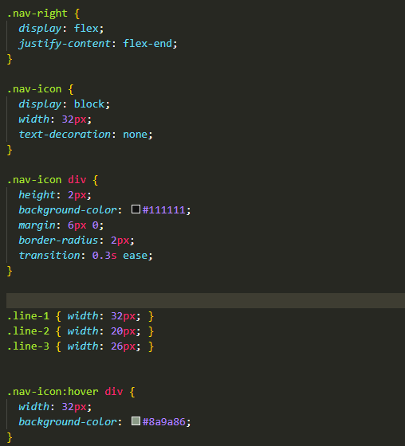
WIREFRAME DESIGN


CODED DESIGNS
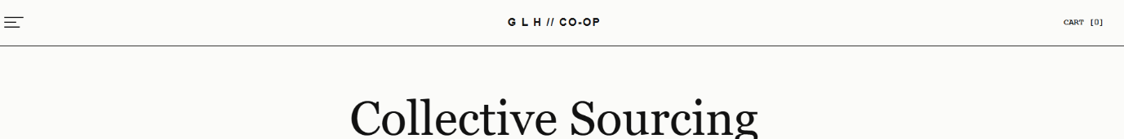
The navigation bar is the main control centre for the site. I used a specific nav tag to help screen reading software identify this as a menu. At this stage, the cart link uses a # as a temporary placeholder this allows me to test the visual layout of it without causing an error by clicking it. This also allowed me to design the look of the bar before the actual cart page was finished. Hero Section & Introductory Content

Hero Section & Introductory Content
Hero section code
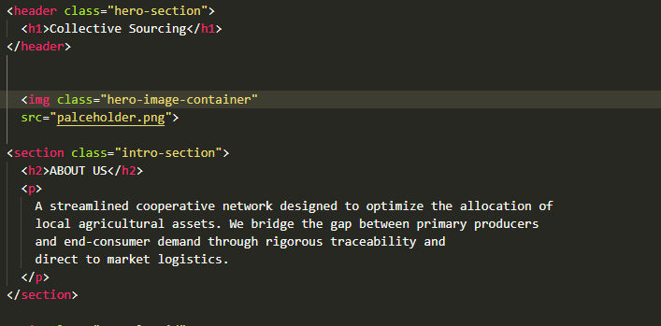

WIREFRAME DESIGN
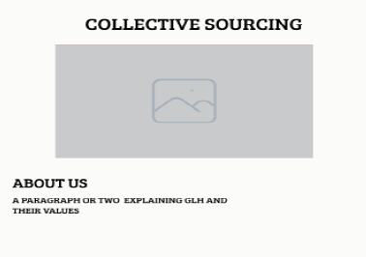
CODED DESIGNS
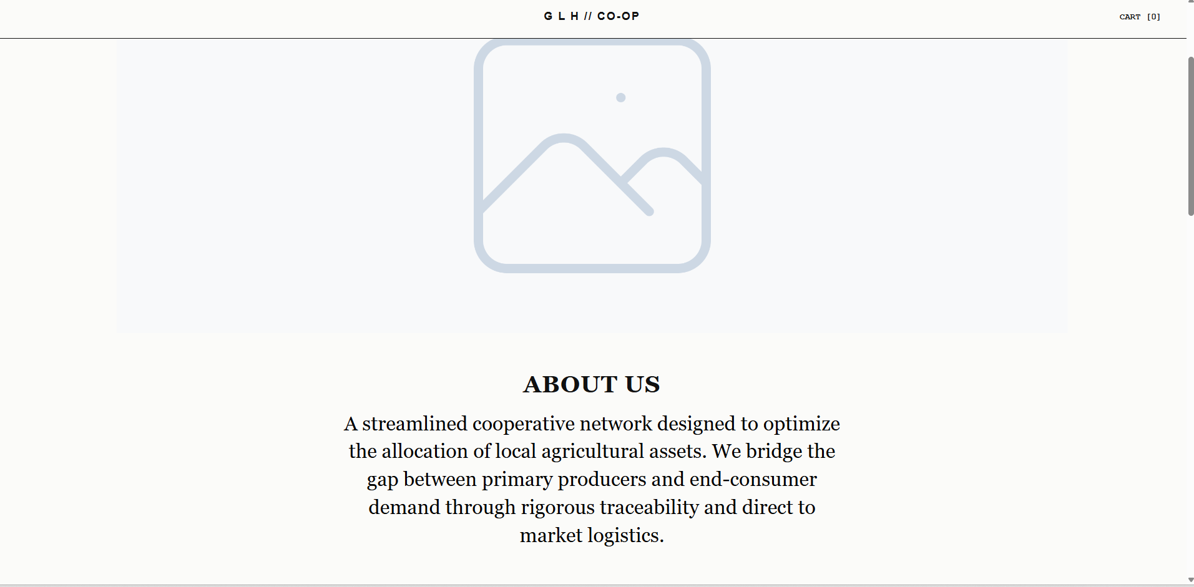
I used proper HTML tags like <section> and <h2> to organise this part of the page. This is an important accessibility feature because it helps screen-reading software understand the layout for visually impaired users. I also used temporary placeholder images and text so I could test the design before the final content was ready.
When I ran my initial UI tests, I noticed a usability problem: the text was too small and cramped against the image, making it hard to read. To fix this issue, I updated my CSS to centre the text, make the font bigger, and add more space around the image. I then ran a regression test, confirming that these changes successfully made the page much easier for users to read.

The Portal Grid
Portal Grid code
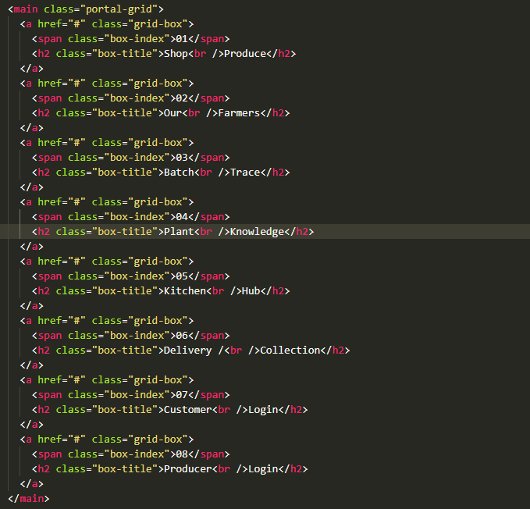

WIREFRAME DESIGN 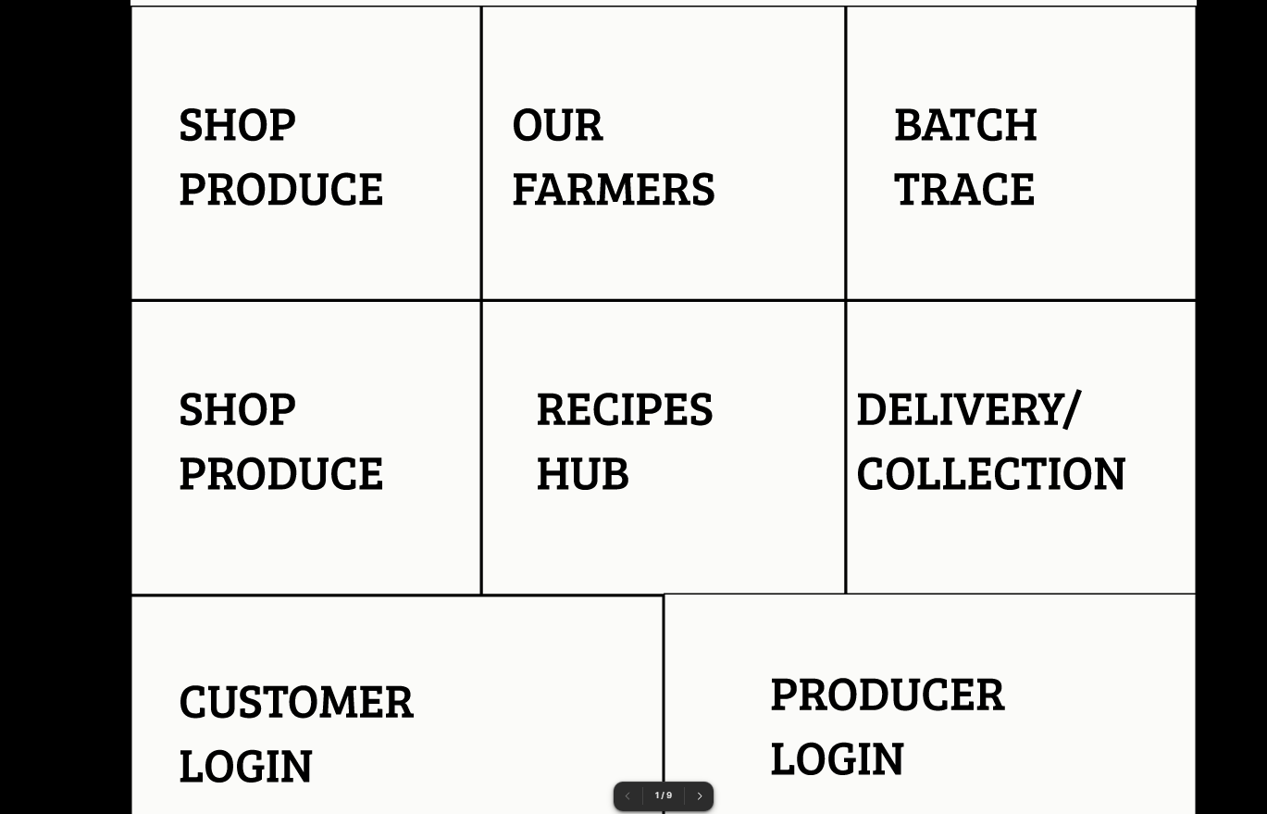
CODED DESIGNS
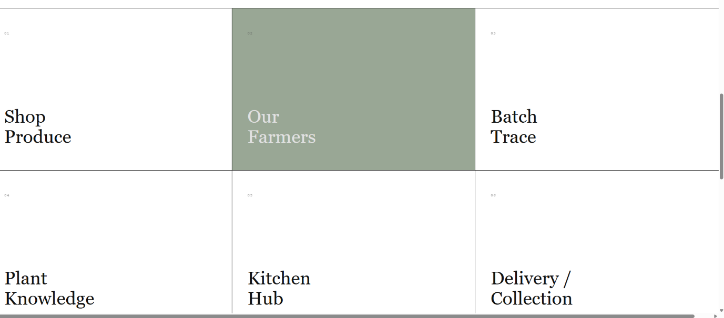
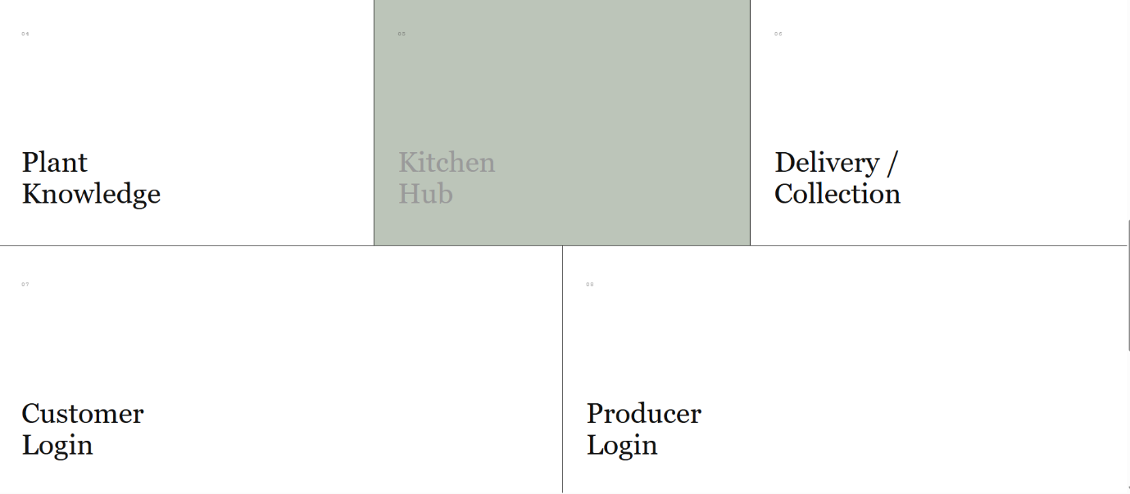

This grid acts as the main form of navigation for the website. To make the site easy to navigate, I wrapped each box inside a link tag. This creates a large clickable area, which is far more user friendly for people using touchscreens compared to small text links and overall, just easier. Like the nav bar all the boxes currently use # placeholders. Since related pages have not been coded yet, these placeholders prevent error messages during testing. Once those pages are developed, the placeholders will be updated.
Overall compared to the wireframe designs the website looks nearly identical, the only changes I’ve made what to add a green hover over the boxes to add some responsiveness to the website and added number id’s (1-8) to the top left of each box. Additionally, I noticed that in my submitted design documents I forgot to change the name of box 4 to ‘plant knowledge’ which will be a page that provides information about the produce sold by GLH

Portal Grid & Typography
BROKEN UI 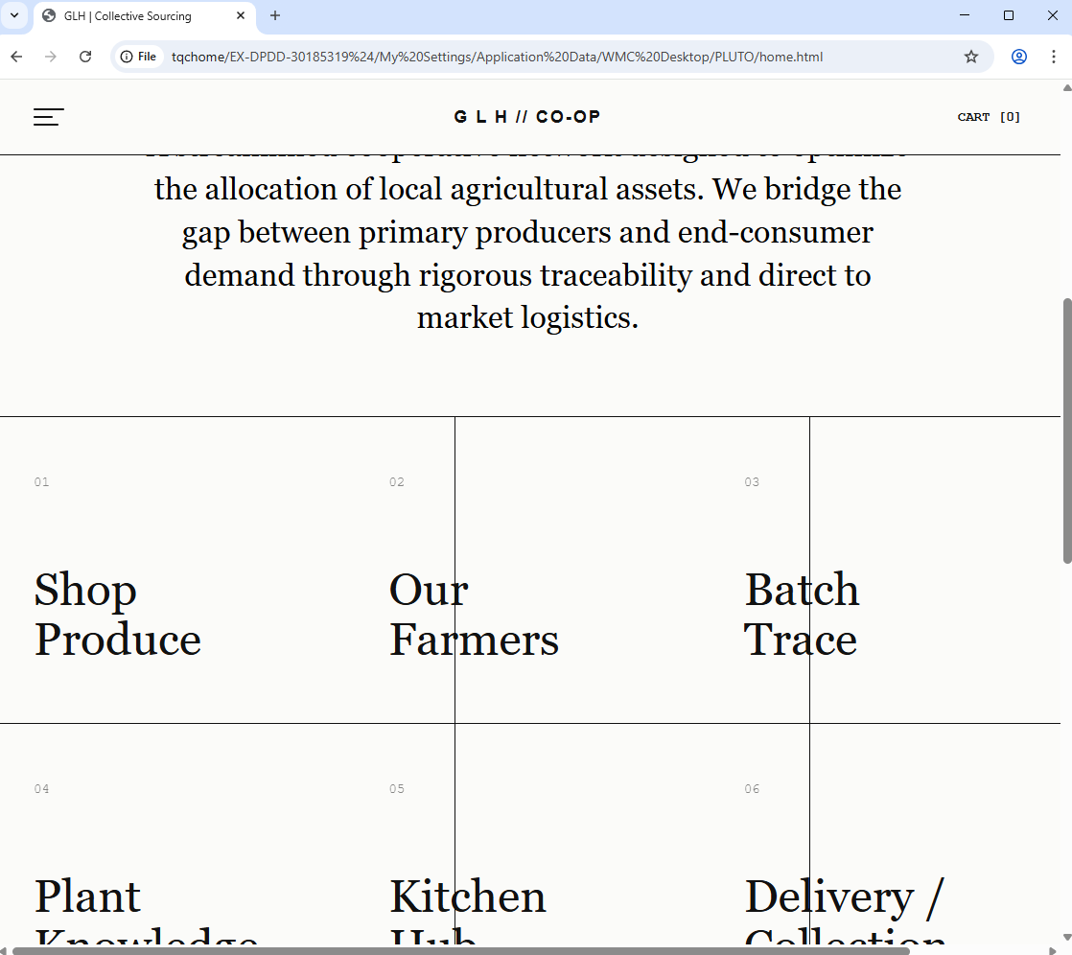
FIXED UI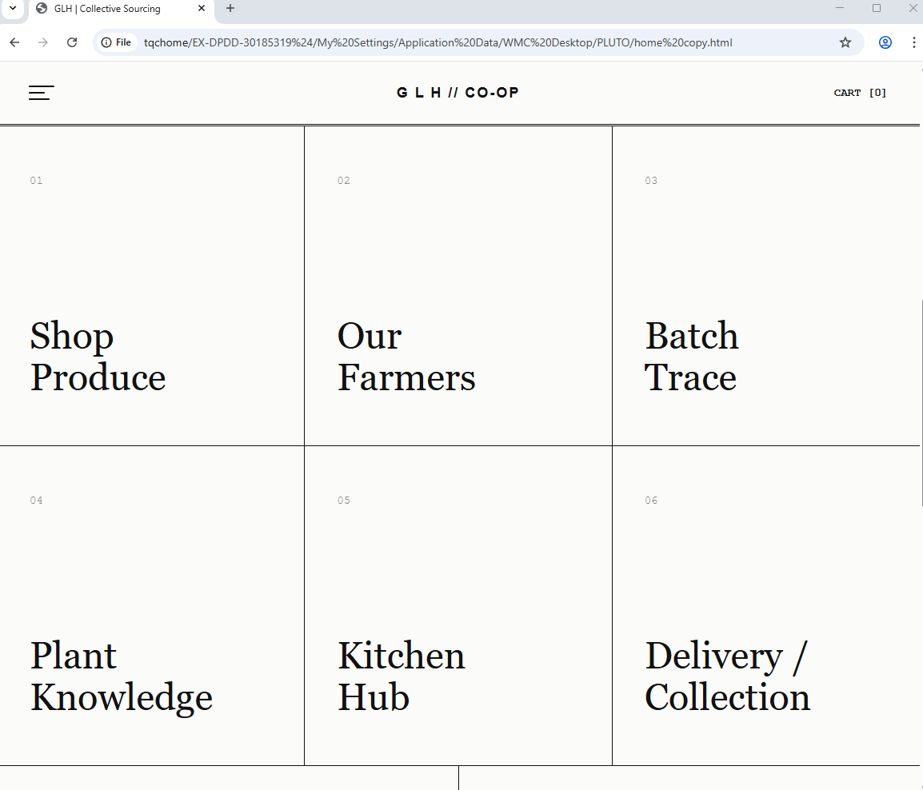
CODE UPDATE
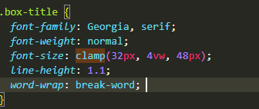
The grid boxes form the main navigational structure of the user interface. During my Black Box UI testing, I discovered a critical responsiveness bug: when resizing the browser window, the fixed 48px font size of the box titles was too large for the container, causing the text to overflow the grid borders and break the UI.
To solve this problem and ensure the layout maintains its architectural integrity across all devices, I completely refactored my typography approach. After researching fluid typography solutions using the official MDN Web Docs
, I replaced the static font sizes with a modern clamp() CSS function. This allows the text to scale dynamically based on the viewport width while remaining locked within a safe minimum and maximum size. A regression test confirmed that all text elements are now perfectly contained within their borders, significantly improving the mobile responsiveness and overall usability of the site.

Grid Responsiveness and debugging
BROKEN UI

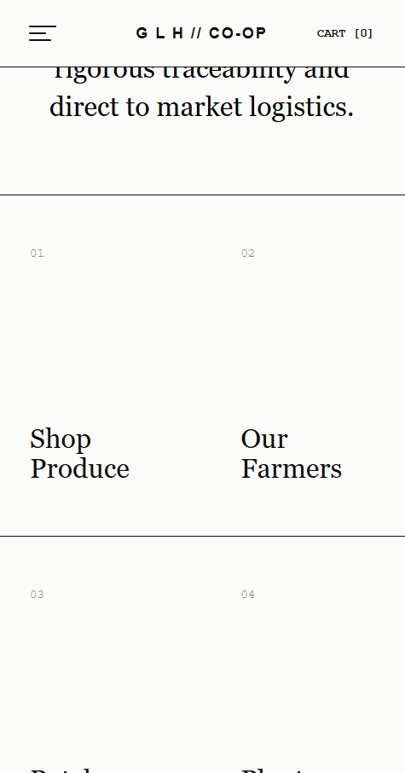

FIXED UI
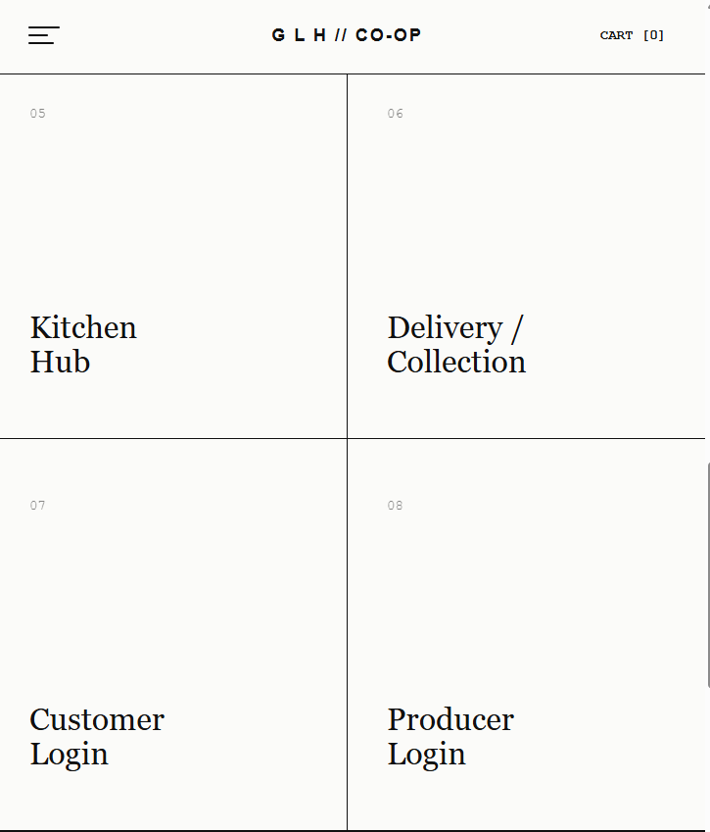
While my initial desktop grid matched the wireframes, extensive Black Box UI testing revealed several critical responsiveness and structural bugs across different screen sizes. Firstly, the fixed 3/2 aspect ratio caused text to overflow its container on midsized screens. I resolved this by changing the aspect ratio to auto and implementing a min-height: 400px rule, allowing the containers to expand vertically to accommodate text wrapping.
Furthermore, my regression testing highlighted a structural issue where the grid lacked a left border, breaking visual continuity. I updated the portal grid class to include a border-left: 1px solid #111111 to restore the outer frame.
Finally, during integration testing for tablet (1024px) and mobile (600px) viewports, I discovered that the high-specificity math of my desktop grid columns was conflicting with my responsive media queries, causing boxes to overflow the viewport and lose their borders. To guarantee cross-device compatibility, I completely refactored my media queries, using !important flags to force the browser to prioritize the 2-column and 1-column layouts at smaller widths. I also added specific border overrides (such as border-bottom: 1px solid) to ensure each item remained distinctly separated. Final regression testing confirmed that these iterative changes successfully created a robust, fluidly scaling grid that preserves its architectural integrity on all devices.
Products page

Shop Produce: Product Grid & Image Scaling
Broken UI
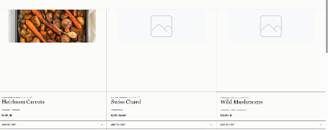
FIXED UI
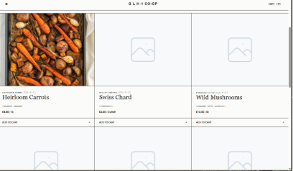

Code snippet
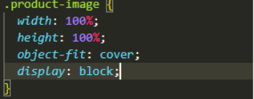
After finishing the homepage, I started building the 'Shop Produce' interface. To keep the design consistent, the product grid reused styles from the global stylesheet. However, when I ran my Black Box UI tests, I found a few layout bugs that needed fixing.
First, the placeholder images were inheriting styles from the hero image, making them look cropped and stretched. I fixed this by creating a new .product-image class with height: 100% and object-fit: cover. Re-testing confirmed this forced the images to fit their boxes perfectly without stretching out of shape.
Next, I noticed that the farm name and product ID were stacked on top of each other on the left side of the card. To make it look cleaner and more organised, I added display: flex and justify-content: space-between to the .product-header. This put the text neatly on one line and pushed the details to opposite sides.
Finally, when testing on tablet sizes (1024px), the grid was stuck in 3 columns, making the cards too narrow and the text hard to read. I updated the 1024px media query to drop the layout to 2 columns using span 1 !important. This made the grid much easier to read and fixed the layout for mid-sized screens.

Our Farmers: Informational Hub
ALTERNATING BOXES
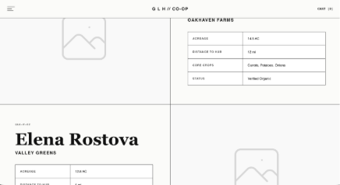
BROKEN MOBILE UI
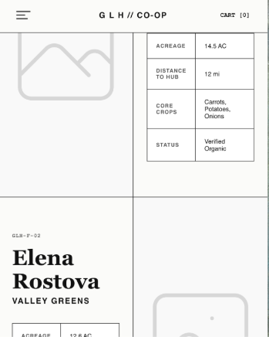
FIXED UI
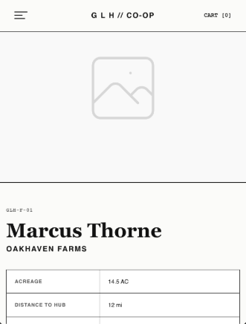
The 'Our Farmers' page acts as the Informational Hub to show users the benefits of buying locally and give them details about the producers. To match the clean look of my wireframes, I used standard HTML <table> tags with border-collapse: collapse to organize the farmer stats (like Acreage and Hygiene Rating) easily. I also used object-fit: cover to make sure the placeholder photos looked professional. Testing confirmed the images filled the space perfectly without leaving empty gaps.
However, when testing different screen sizes, I found a major bug at the 1024px (tablet) width. The grid stayed stuck in a 50/50 split, which squeezed the text and made it hard to read.
To fix this, I added a @media (max-width: 1024px) query to change it to a single-column layout. But because the desktop design alternates the images (left, then right), the text ended up stacking on top of the image on every second row. To fix this and keep the mobile view consistent, I added order: 1 !important to the images in the media query. This ensures the images always stay above the text on smaller screens, no matter how they are arranged on desktop. A final test showed the mobile layout is now easy to read without breaking the desktop design

Role-Based Login Interfaces (Customer & Producer)
CUSTOMER LOGIN
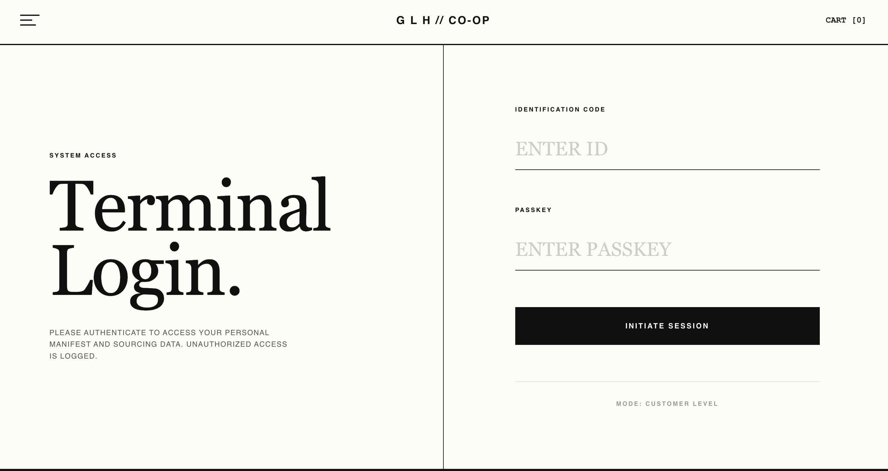
PRODUCER LOGIN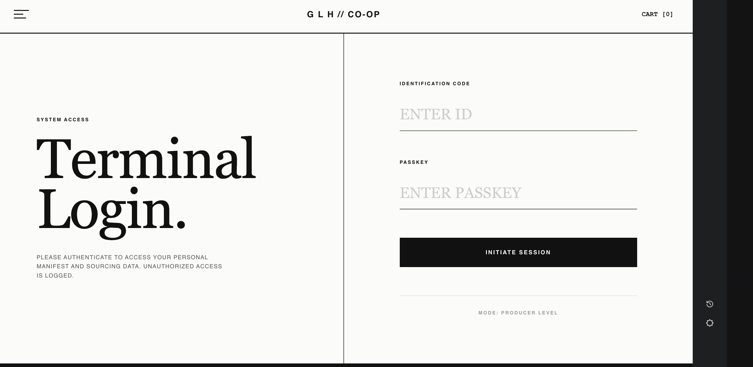

I built the 'Customer Login' form first, using standard HTML <form> tags and integrating the global typography CSS. This ensured the form perfectly matched the minimal layout from my original wireframes and maintained the highly compliant contrast ratio established in my design documents. Because the 'Producer Login' terminal required the exact same visual structure, I duplicated the HTML and simply updated the text to match the producer page wireframes where required. This ensured perfect visual consistency across the platform without needing duplicate CSS rules.
When I ran my initial UI tests, I noticed a usability problem: I had forgotten the placeholder text for the password fields, leaving them blank. To fix this issue, I updated the HTML <input> tags to include placeholder="ENTER PASSKEY", which immediately improved user guidance.
Furthermore, to prevent users from submitting empty forms, I added the native ‘required’ attribute to all input fields. A regression test confirmed that the browser successfully intercepts empty submissions with a native error prompt, enforcing strict client-side validation before I begin coding the back-end PHP.

Active Cart & Checkout Interface
WIREFRAME DESIGN
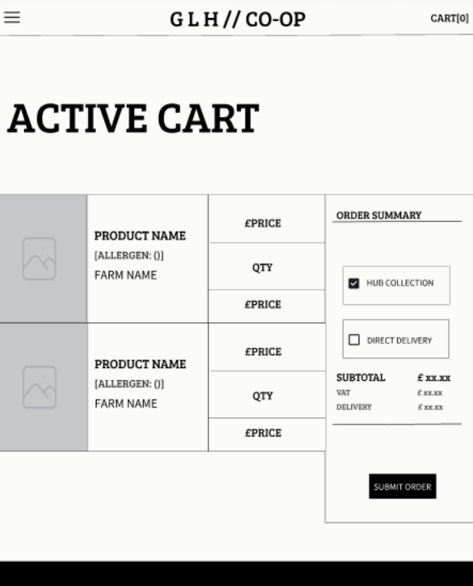

CODED DESIGN
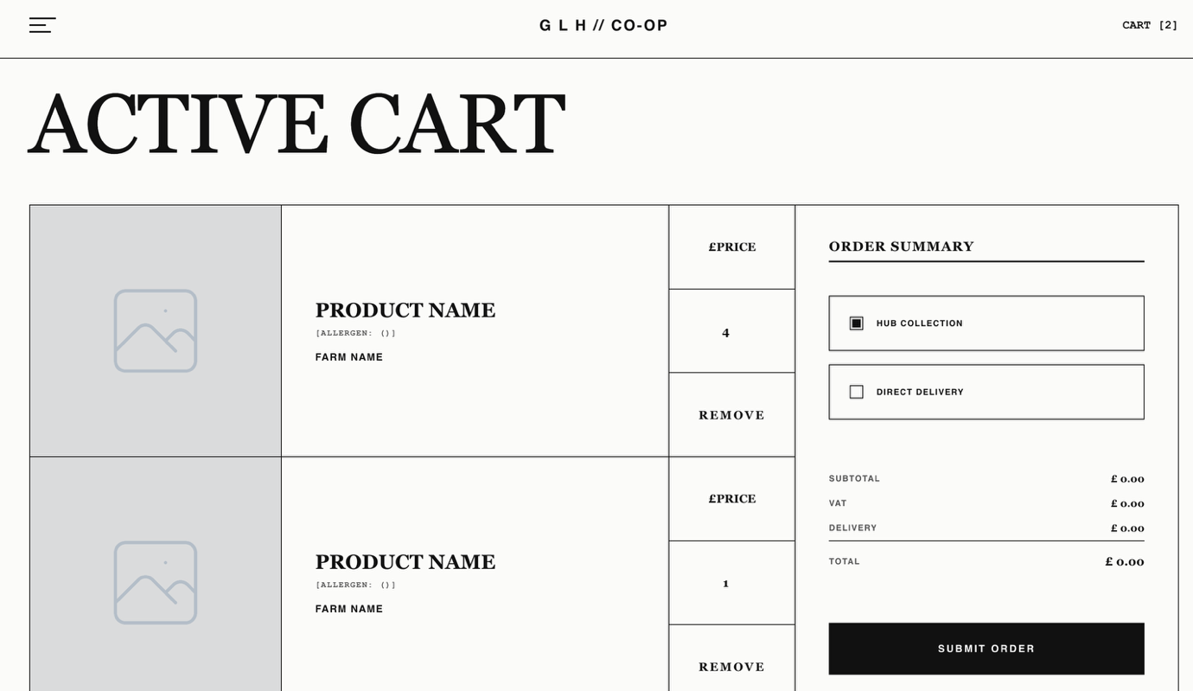
To meet the strict 'Must Have' project requirement of providing customers with flexible scheduling options, I built the Active Cart interface using standard HTML <form> tags, specifically incorporating clear tick boxes for "Hub Collection" and "Direct Delivery". I maintained a minimal, high-end layout to display the product names, allergens, and pricing without unnecessary clutter.
During my initial UI testing, I encountered a layout bug: the cart items and the order summary were acting like a standard webpage and stacking vertically instead of splitting side by side. To fix this issue, I updated the CSS to use a structured grid layout (grid-template-columns: 2fr 1fr). I also implemented a gap: 1px technique to instantly generate the borders required by my design system. A regression test confirmed that this successfully prevented any nested images from overlapping the grid lines.
While conducting integration testing for tablet viewports (1024px), I noticed another issue: the grid remained stuck in the desktop layout, forcing content off the screen and creating a horizontal scrollbar. I realised I had accidentally placed the mobile CSS rules outside the intended styling block. I moved the cart logic inside the correct @media (max-width: 1024px) block, ensuring the layout properly collapses into a single, readable column on smaller screens.
Finally, as evidence of refining features rather than just building them once, I improved the usability of the cart management. I added a CSS :hover state to the "REMOVE" button so that it smoothly animates to a high-visibility red. This provides clear, immediate visual feedback to warn the user that they are about to delete an item, enhancing the user experience without breaking the aesthetic.

Batch Trace
WIREFRAME DESIGN
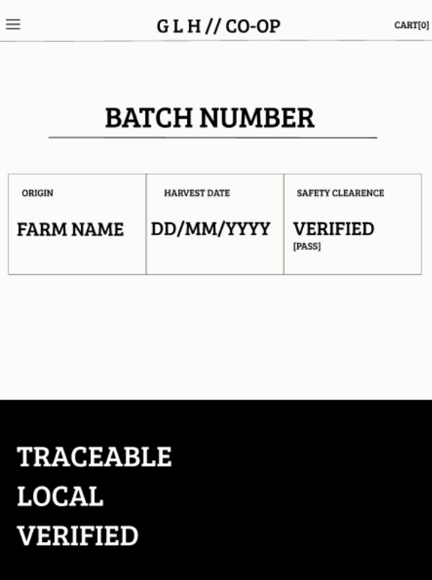
CODED DESIGN
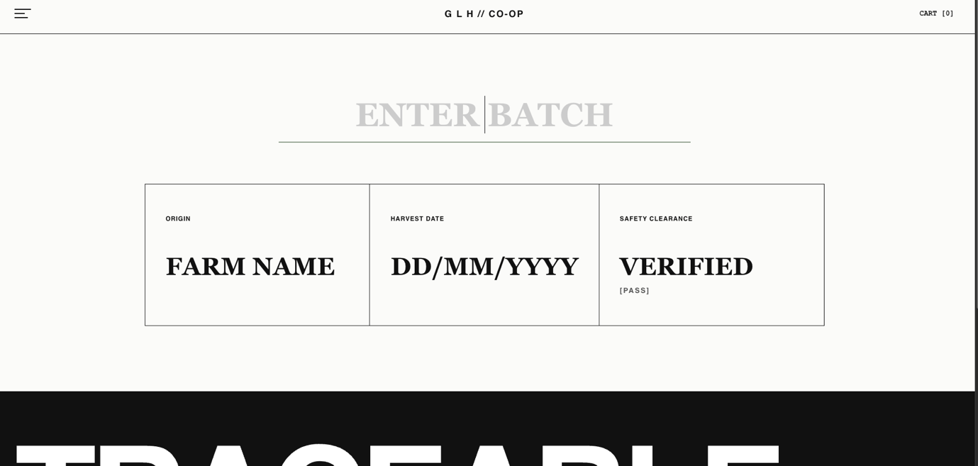
To directly answer the 'Must Have' project requirement for strict HACCP traceability and product recalls, I developed the Batch Trace interface. My goal was to keep the layout clean and data-focused so users can instantly verify the origin and safety clearance of their food. I changed the “Batch number” input from the wireframe to “Enter Batch” as it is more descriptive for the customer. I also changed the colour of the input from black to grey so that its easily identified as an input field
While the page successfully inherited my global typography and spacing, I encountered a responsiveness bug during my initial UI testing. When scaling down to tablet and mobile viewports (< 1024px), the .batch-grid component failed to collapse. It remained locked in a forced 3 column layout (grid-template-columns: repeat(3, 1fr)), which caused horizontal compression and made the traceability data fields completely unreadable on smaller screens.
To resolve this layout break, I integrated the .batch-grid and .batch-cell into my @media (max-width: 1024px) CSS block. By forcing a 1fr column template, the module now correctly stacks vertically at 100% width. A regression test confirmed that this fix successfully preserves the structural integrity and readability of the data across all widths.

Producer Terminal (Dashboard)
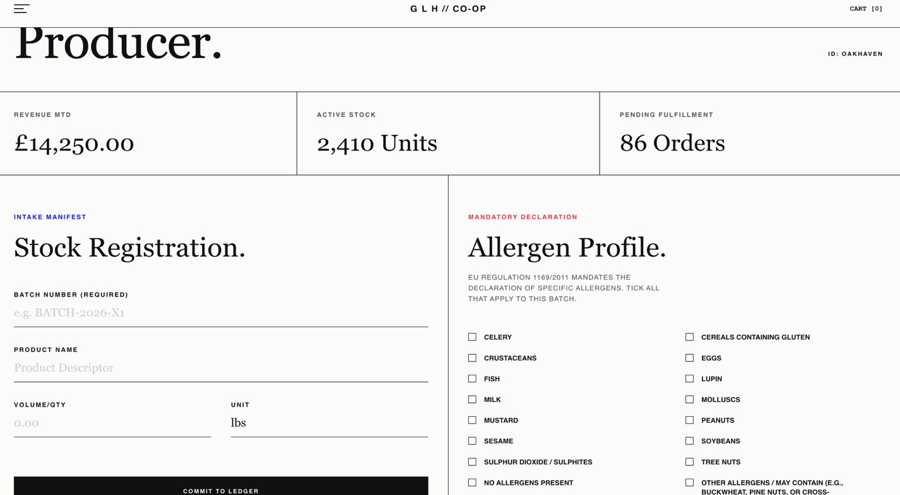
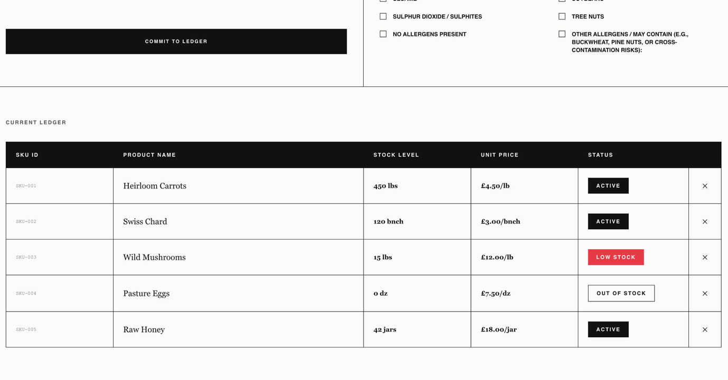
To directly answer the 'Must Have' project requirements for inventory management and legal compliance, I built the Producer Terminal
My primary focus was keeping the HTML layout clean, professional, and free of unnecessary colours so local farmers can input their stock data quickly and efficiently without confusion. For the 'Active Stock' tracking, I utilised structured HTML <table> tags to ensure the inventory data will be displayed clearly once connected to the database
The most critical component of this interface is the 'Allergen Profile' form. To ensure strict compliance with Natasha's Law, I explicitly built the 14 mandatory allergen tick boxes into the HTML layout. This structural design ensures producers cannot miss this step, directly answering my Risk Mitigation strategy to prevent severe health consequences and legal liabilities.
However, during a Logic Review and UI usability test, I discovered a major logical flaw in my initial Task 1 wireframe design. I reviewed the built HTML form against my planned backend validation (Algorithm 3, which is designed to physically block product submissions if the allergen array is empty). I realised that farmers trying to sell raw, allergy-free produce (like fresh carrots) would be completely blocked by the system or forced to submit false data
Catching this logical flaw before coding the PHP backend saved significant development time. I proactively improved the UI by adding a 15th "No Allergens Present" checkbox to the HTML form. This improves usability and ensures that when the backend is built, farmers can legally verify their produce is safe without triggering false errors.
After conducting further research, I discovered the ‘Other Allergens / May Contain’ option and decided to include it as well. This led to the addition of a 16th input field, enabling producers to enter custom string data for any emerging allergen risks. This enhancement ensures that the UI can capture comprehensive safety information and transmit it accurately to the PHP backend, meeting critical functional requirements and safeguarding both the cooperative and the end-consumer.
To directly answer the client's mandatory requirement enabling producers to "manage stock levels", I reviewed the Producer Terminal page and while the main registration panel successfully handled the 'Create' and 'Update' functionalities, I realised that there was no option to remove stock. I then added a new "[X/Remove]“ button next to the table cells, allowing farmers to efficiently delete stock. To mitigate the risk of accidental data loss, I implemented a CSS :hover state that smoothly animates to a high-visibility red. This provides clear, immediate visual feedback to warn the user before deletion, enhancing the overall user experience without breaking the table's responsive aesthetic.

Account Registration (Sign Up)
MEMBER REGISTRATION
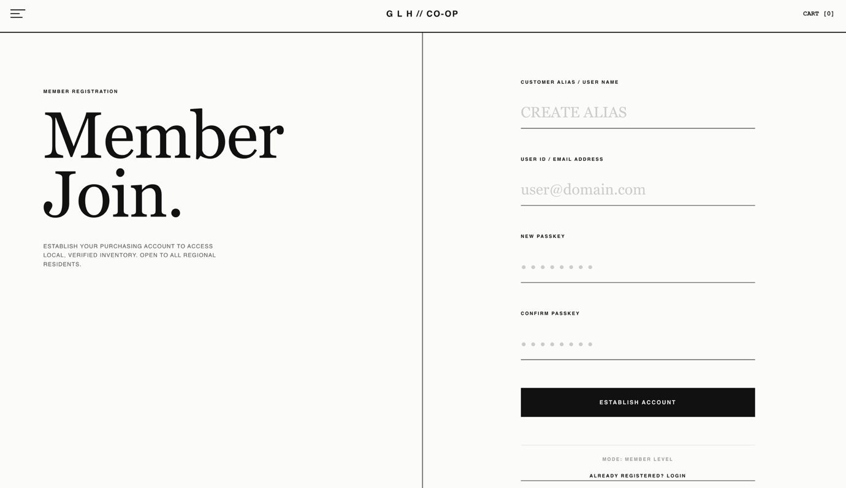

PRODUCER REGISTRATION
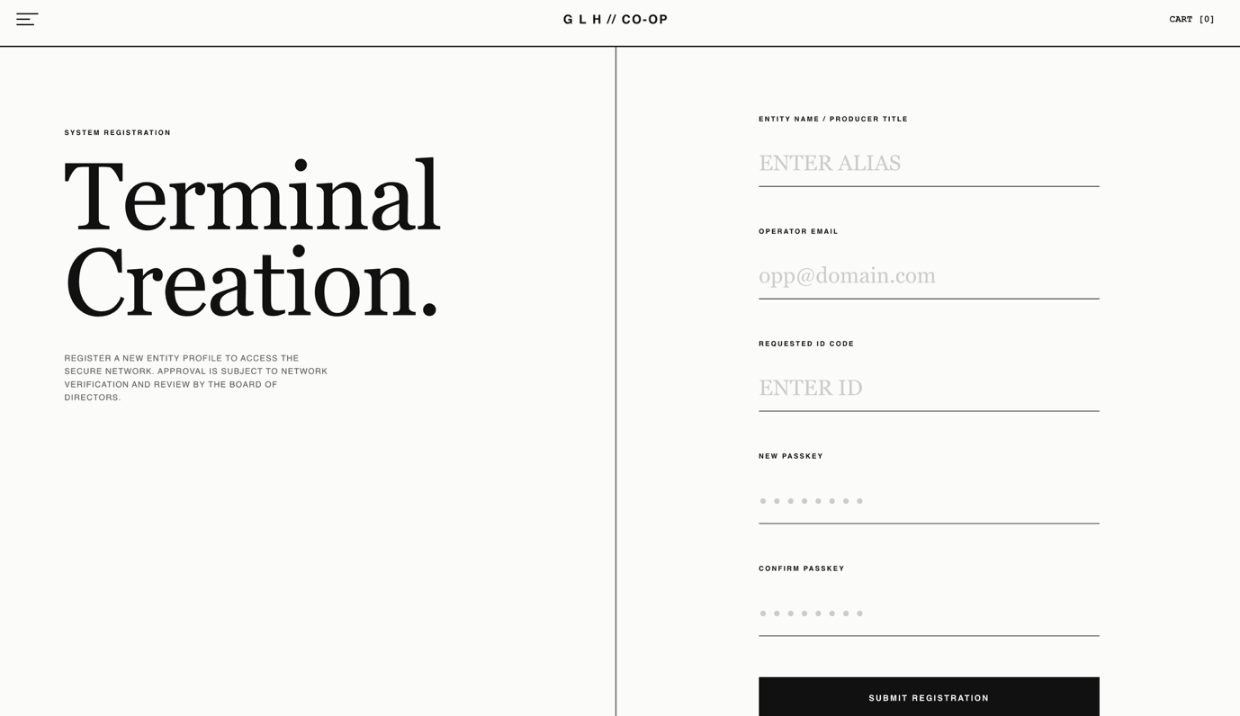
To complete the "Register, Login, Manage" user account loop required by the project brief, I built the Account Registration interface. By intentionally inheriting the global CSS from the existing Login interfaces, I ensured a highly seamless and "clear and consistent UI" across all authentication pages.
Crucially, to ensure a flawless user journey and prevent navigational dead-ends, I established a bi-directional routing loop between these terminals. I proactively updated the HTML of both the Customer and Producer Login pages to include direct "Create an Account" links, instantly redirecting new users to the registration form. Conversely, I included an "Already have an account? Login here" link on the sign-up page. This UX design ensures users can seamlessly switch between registering and logging in without having to rely on the browser's back button, fulfilling the requirement for a logical flow between pages.
Furthermore, I implemented strict client-side validation during this front-end phase to enhance security and adhere to secure coding practices. By applying the required attribute to all inputs, and specifically using type="email" for the email field, I ensured that the browser actively intercepts empty submissions or badly formatted data before it ever reaches the backend database

Global Navigation Menu (Drawer)
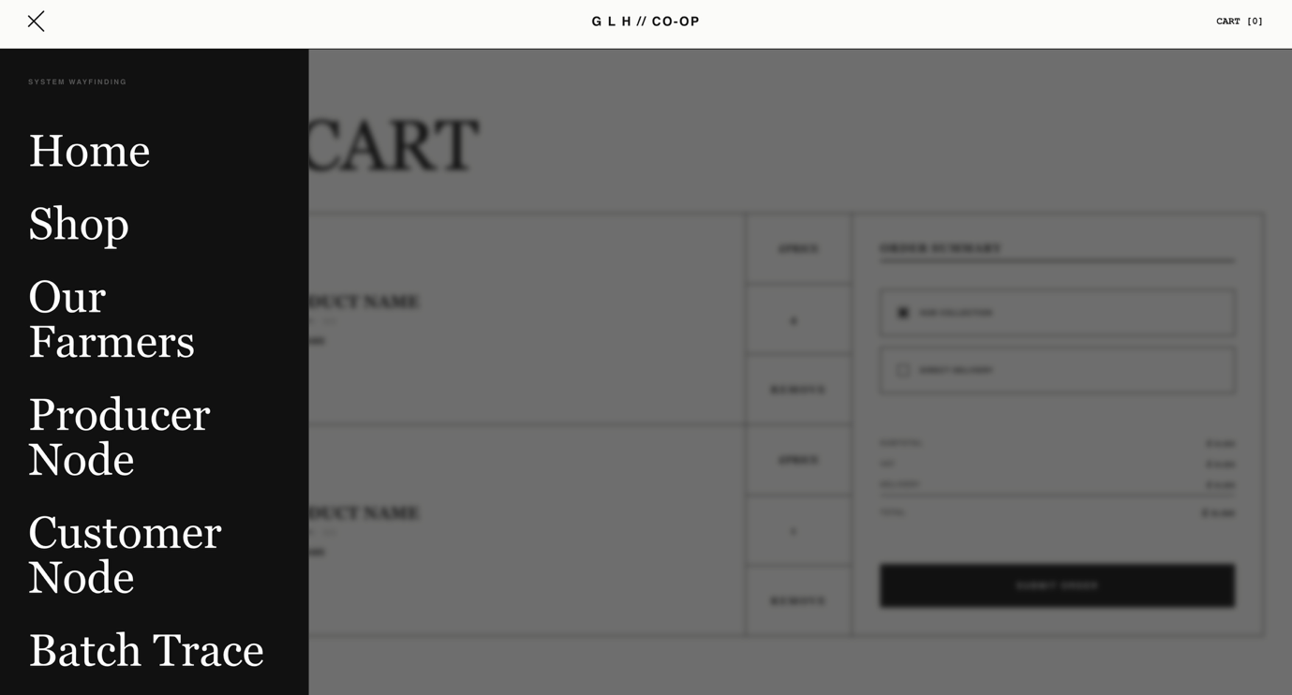

With the core HTML interfaces built, my next focus was finalising the navigation structure. To ensure logical flow between pages, I replaced all the temporary # placeholder links within the global menu drawer with functional relative file paths. Integration testing confirmed that the navigation system is now fully operational and successfully interconnects the current front-end prototype without any 404 routing errors, directly fulfilling the core requirement for clear site navigation.
However, during Black Box UI testing of the menu drawer on mobile viewports (scaled down to 400px), I discovered a structural responsiveness issue. The navigation drawer was expected to scale down proportionally with the page while maintaining appropriate horizontal padding on the right. Instead, the menu expanded to take up 100% of the viewport width, completely stripping away the intended side margins. This caused the menu to spread flush against the edges of the screen, creating a cramped and unpolished layout.
To resolve this UX flaw and maintain structural whitespace, I refactored the mobile CSS for the menu container. I implemented the mathematical CSS function width: calc(100% - 60px);. This highly responsive rule ensures the drawer dynamically scales to the size of any mobile device while strictly reserving a 60-pixel vertical column on the right side. This leaves a portion of the current background page visible, maintaining the user's spatial awareness. Regression testing verified that the CSS width fix worked exactly as intended, ensuring the global menu is now fully mobile-responsive and maintains a highly usable, premium layout across all device sizes.

GDPR & Data Privacy (Full-Screen Consent Wall)
CODED DESIGN
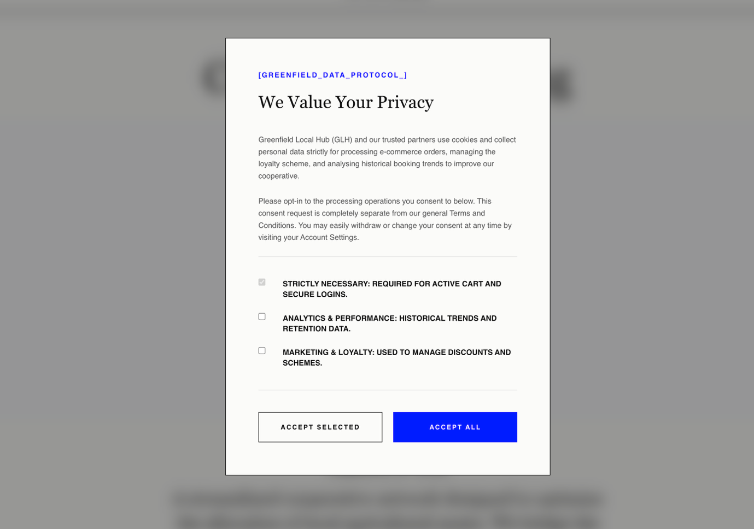
After reviewing my task 1 proposal, I realised I still needed a way to capture explicit user consent to meet the strict data protection and GDPR requirements. Instead of a small pop up, I built a full screen consent wall that appears on a user's first visit. This ensures users actively address their data privacy preferences before they can access the main shop.
To comply with GDPR laws, the form separates data consent from the general Terms and Conditions. It offers granular options so users can independently choose to accept "Strictly Necessary," "Analytics & Performance," or "Marketing & Loyalty" tracking. I also made sure the HTML checkboxes are unticked by default, so users are forced to actively opt-in or continue with just the strictly necessary cookies.
Code Organisation and Maintainability
As I was finishing up the front-end development, I went back over my CSS file to reorganise it. I separated the styles into clear, logical sections and added block comments to explain key parts of the code. I did this specifically to make the stylesheet much more readable, ensuring that the code is structured, organised, and easy for any external third-party developer to understand and maintain in the future

